AI LAB MANUAL – LAB 3
TASK 1: BFS AND DFS MANUAL TRACE
Uninformed Search: Breadth-First Search and Depth-First Search
1. Objective
Manually trace Breadth-First Search (BFS) and Depth-First Search (DFS) on the graph given in the lab manual. The start node is A and the goal node is G. Successors are considered in the exact order listed in the graph.
2. Given Graph
graph = {
"A": ["B", "C"],
"B": ["D", "E"],
"C": ["F"],
"D": [],
"E": ["G"],
"F": [],
"G": []
}
Start node: A | Goal node: G
Graph structure: A connects to B and C; B connects to D and E; C connects to F; E connects to G. D, F and G have no successors.
3. Breadth-First Search (BFS)
BFS explores the graph level by level. It uses a FIFO queue (First In, First Out). At each step, remove the front node, process it, and add its unvisited successors to the rear of the queue in the listed order. The trace stops when G is processed.
Step | Processed node | Successors added | Queue after processing
1 | A | B, C | [B, C]
2 | B | D, E | [C, D, E]
3 | C | F | [D, E, F]
4 | D | — | [E, F]
5 | E | G | [F, G]
6 | F | — | [G]
7 | G (goal) | — | [] – stop
BFS processing / visit order: A → B → C → D → E → F → G
BFS solution path: A → B → E → G. This is the path returned when the goal is reached.
4. Depth-First Search (DFS)
DFS explores one branch as deeply as possible before backtracking. It uses a LIFO stack (Last In, First Out). To process successors in the graph's listed order, successors are pushed onto the stack in reverse order. The rightmost item below is the top of the stack.
Step | Processed node | Push order | Stack after processing (top at right)
1 | A | C, then B | [C, B]
2 | B | E, then D | [C, E, D]
3 | D | — | [C, E]
4 | E | G | [C, G]
5 | G (goal) | — | [C] – stop
DFS processing / visit order: A → B → D → E → G
DFS solution path: A → B → E → G. Node C remains on the stack when the goal G is processed.
5. Comparison and Final Results
Algorithm | Visit / processing order | Final path to goal | Nodes processed
BFS | A → B → C → D → E → F → G | A → B → E → G | 7
DFS | A → B → D → E → G | A → B → E → G | 5
Both algorithms find the same solution path in this graph: A → B → E → G. BFS processes nodes level by level, so it processes C, D and F before reaching G. DFS follows the first listed branch deeply: A, then B, then D, then backtracks to E and reaches G.
6. Verification Notes
The successor order from the supplied graph is preserved.
BFS uses a queue and removes nodes from the front.
DFS uses a stack; successors are pushed in reverse order so the first listed successor is processed first.
The goal test is applied when a node is processed (removed from the queue or stack), and the trace stops at G.
Visit order is reported separately from the final solution path.
End of Task 1

Lab 3 – Task 2 Report
Depth-Limited Search (DLS) and Iterative Deepening DFS (IDDFS)
Course: CAI601400 – Artificial Intelligence Student: Amina Mustafa – Roll No. 329

1. Problem Statement
A rescue robot searches an emergency-exit map without any heuristic. The task is to implement Depth-Limited Search (DLS) and Iterative Deepening DFS (IDDFS) on the supplied A–G graph, with start A and goal G, test depth limits 1, 2, 3 and 4, and report the status (FOUND, CUTOFF or FAILURE), the path and the limits attempted.

2. Assumptions
- Graph is the original A–G graph from Section 3.2; the root A has depth 0 and depth counts edges.
- Successor-list order is the tie-breaking order (left to right): A→[B,C], B→[D,E], C→[F], E→[G].
- Cycle check is path-local: a successor is skipped only if it is already on the current path. No global visited set is carried across depth limits.
- Goal node is counted in the number of processed nodes.

State-space formulation
Component | Definition
Initial state | A
Actions / successors | Move along an outgoing corridor: A→B, A→C, B→D, B→E, C→F, E→G
Goal test | node == G
Path cost | 1 per edge (depth = number of edges)

Only exit route: A → B → E → G (depth 3).

3. Implementation Choices
- Three-way result. dls() returns FOUND with a path, CUTOFF if a deeper unexplored continuation exists beyond the limit, or FAILURE if the explored branch is exhausted.
- CUTOFF vs FAILURE at the limit. When limit reaches 0 the node returns CUTOFF only if it still has successors not on the current path; a leaf (e.g. D or F) returns FAILURE.
- IDDFS. Calls DLS with limits 0, 1, 2, … up to the maximum depth, each time with a fresh path-local check. It stops on FOUND, or on FAILURE (whole graph exhausted, so no deeper limit can help).
- Work counter. Every processed node is recorded so repeated work in IDDFS can be measured.

5. Results

5.1 DLS at limits 1–4
Limit | Status | Path | Nodes processed (order)
1 | CUTOFF | None | A, B, C
2 | CUTOFF | None | A, B, D, E, C, F
3 | FOUND | A → B → E → G | A, B, D, E, G
4 | FOUND | A → B → E → G | A, B, D, E, G

5.2 IDDFS with maximum depths 1–4
Max depth | Status | Path | Limits attempted | Total nodes processed
1 | CUTOFF | None | 0, 1 | 4
2 | CUTOFF | None | 0, 1, 2 | 10
3 | FOUND | A → B → E → G | 0, 1, 2, 3 | 15
4 | FOUND | A → B → E → G | 0, 1, 2, 3 | 15

Note: for max depth 4, IDDFS stops after limit 3 because G is found there; limit 4 is never needed.

6. Interpretation

Why limits below 3 do not succeed
G lies at depth 3 (A→B→E→G). With limit 1 the search reaches B and C but cannot expand them; with limit 2 it reaches D, E and F but cannot expand E, which holds the only link to G. Both runs return CUTOFF, meaning the failure is due to the bound, not to G being unreachable. At limit 3 the edge E→G is within reach, so the result is FOUND.

Repeated work in IDDFS
IDDFS re-expands the shallow nodes at every iteration. Processed nodes per iteration: limit 0 → 1 (A), limit 1 → 3 (A, B, C), limit 2 → 6 (A, B, D, E, C, F), limit 3 → 5 (A, B, D, E, G). Total = 1 + 3 + 6 + 5 = 15 versus 5 for a single DLS at limit 3. This overhead is small because most nodes in a tree sit at the deepest level, and in return IDDFS gets DFS-like memory use with BFS-like completeness and optimality for equal step costs.

DLS vs IDDFS
DLS needs the correct limit to be known in advance: a limit that is too small gives CUTOFF, and a limit that is too large may return a longer path in other graphs. IDDFS removes this guesswork by trying 0, 1, 2, … so the first FOUND is the shallowest solution.

7. Edge-Case Tests
Test | Result | Observation
Start equals goal (A, A) | FOUND, path [A] | Goal test is applied before expansion, so limit 0 is enough.
Unreachable goal (isolated H) | FAILURE, limits 0–3 | Whole graph exhausted, so IDDFS stops early instead of running to the maximum.
Cycle A→B→C→A, goal D | FOUND, A→B→C→D | Path-local check skips C→A and prevents an infinite loop.
Cycle graph, goal Z (isolated) | FAILURE, limits 0–3 | No infinite recursion; search ends with FAILURE.

8. Failure / Edge Case Analysis
- Input: DLS with limit 2 on the original graph, goal G.
- Observed behaviour: status CUTOFF, no path returned.
- Likely cause: G is at depth 3, one level beyond the limit. CUTOFF does not mean G is unreachable; it is only a bounded-search result.
- Proposed improvement: use IDDFS (or increase the limit when CUTOFF is returned) so the limit grows automatically until FOUND or FAILURE.
Why not a global visited set: a node first reached at a deep level in one iteration could be wrongly suppressed when it is reachable by a shorter path in a later iteration. The path-local check avoids cycles while keeping such valid revisits.

9. Viva-Ready Design Explanation
- Why three statuses? CUTOFF means "try a larger limit"; FAILURE means "no solution in this branch at all". Mixing them gives wrong conclusions.
- Why path-local cycle check? It prevents infinite loops without blocking valid revisits across iterations.
- Complexity: DLS time O(b^l), space O(b·l); IDDFS time O(b^d), space O(b·d). Here b ≤ 2 and d = 3.
- IDDFS is complete and optimal (equal step cost), unlike plain DFS or DLS with an arbitrary limit.

10. Reflection
- What I learned: a depth limit changes DFS into a bounded search, and CUTOFF must be kept separate from FAILURE.
- What surprised me: IDDFS repeats work (15 vs 5 node visits) yet costs little extra.
- Real AI use: robot navigation or puzzle solving where the goal depth is unknown and memory is limited.
- Next time: also count generated nodes, and test larger graphs with many cycles.

11. Appendix: Python Code (Screenshots)
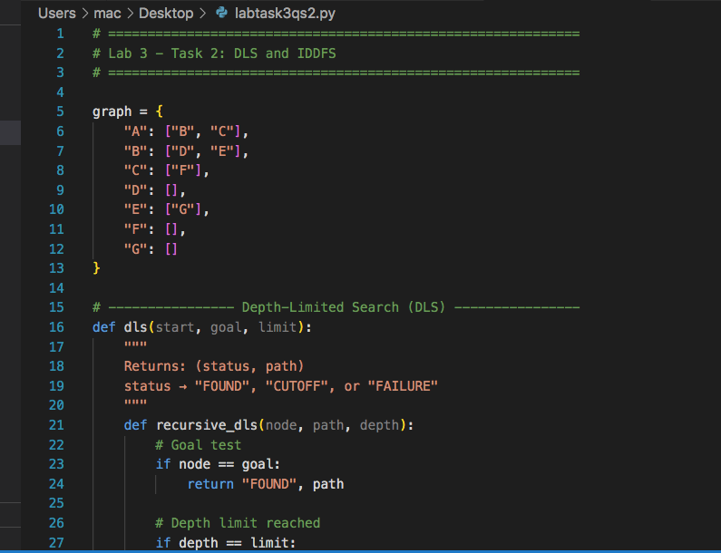
Figure 2: lab3_depth_search.py – graph, dls(), run_dls() and iddfs()
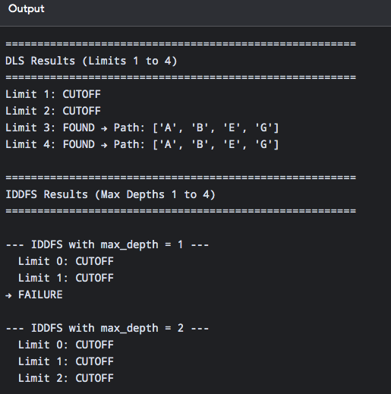

Lab 3 – Task 3 Report
Uniform Cost Search (UCS) on a Weighted Emergency-Exit Graph
Course: CAI601400 – Artificial Intelligence Student: Amina Mustafa – Roll No. 329

1. Problem Statement
In an emergency-exit graph the route with the fewest edges is not always the cheapest. The task is to create a weighted version of the A–G graph, find the minimum-cost path from A to G with Uniform Cost Search (UCS), verify the path cost independently, compare it with the route found by BFS on the same weighted topology, and explain why a shorter-hop route can cost more.

2. Assumptions
- Start is A and goal is G. Successor-list order is the tie-breaking order.
- All weights are nonnegative travel-cost units (UCS is not valid for negative edges).
- The original graph is kept and one corridor, C → G, is added as documented in Section 3.7 of the manual. This extension is used only for the weighted experiment; the original manual-trace graph is unchanged.
- The manual does not list numeric weights, so I chose weights that match the manual’s statement: BFS route A→C→G costs 12, UCS route A→B→E→G costs 3.
- Goal processing is included in the reported processing order.

3. Weighted Graph
From | To | Weight | Note
A | B | 1 | Original corridor
A | C | 5 | Original corridor
B | D | 4 | Original corridor
B | E | 1 | Original corridor
C | F | 3 | Original corridor
E | G | 1 | Original corridor
C | G | 7 | ADDED corridor (Section 3.7 extension)

Candidate routes to G: A→B→E→G (3 edges, cost 1+1+1 = 3) and A→C→G (2 edges, cost 5+7 = 12).

4. Implementation Choices
- Priority queue. UCS uses heapq, ordered by accumulated path cost g(n).
- Tie-breaking. A counter is stored in each heap entry so equal-cost nodes leave the queue in the order they were inserted.
- Stale entries. A node may be pushed more than once; already processed nodes are skipped when popped.
- Goal test on pop. The goal is tested when a node is removed from the queue, not when it is generated, which is what makes UCS optimal.
- Validation. A check rejects negative edge weights before searching.
- Independent check. path_cost() adds the edge weights of a returned path separately from the search.

6. Results

6.1 UCS processing trace (A to G)
Step | Processed | g(n) | Frontier after expansion (node(cost))
1 | A | 0 | B(1), C(5)
2 | B | 1 | E(2), C(5), D(5)
3 | E | 2 | G(3), C(5), D(5)
4 | G | 3 | Goal reached – stop

UCS processing order: A, B, E, G. Path: A → B → E → G. Cost: 3.

6.2 UCS vs BFS on the same weighted topology
Algorithm | Path | Edges | Cost | Processing order
BFS | A → C → G | 2 | 12 | A, B, C, D, E, F, G
UCS | A → B → E → G | 3 | 3 | A, B, E, G

6.3 Independent cost verification
Path | Sum of edge weights | Total
A → B → E → G | w(A,B) + w(B,E) + w(E,G) = 1 + 1 + 1 | 3
A → C → G | w(A,C) + w(C,G) = 5 + 7 | 12

Both totals match the values printed by the program.

7. Interpretatio.

Why UCS processes fewer nodes here
UCS processed 4 nodes (A, B, E, G) while BFS processed all 7. UCS always expands the cheapest frontier node, so it reaches G with cost 3 before the costlier nodes C(5) and D(5) are ever expanded. This is a property of this graph, not a general guarantee: UCS can expand many nodes when many cheap edges exist.

Completeness and optimality
UCS is complete and optimal when all edge costs are positive (or nonnegative, with care for zero-cost cycles). BFS is optimal only when every step has equal cost.

8. Edge-Case Tests
Test | Result | Observation
Start equals goal (A, A) | Path [A], cost 0 | Goal test passes on the first pop.
Unreachable goal (isolated H) | None, cost = infinity | Frontier empties; no path is invented.
Cycle A→B→A (weights 2 and 1) | Path A→B→C, cost 4 | Processed set stops infinite looping.
Negative edge A→B = −2 | ValueError raised | UCS needs nonnegative costs.

9. Failure / Edge Case Analysis
- Input: a graph containing a negative edge weight (A → B = −2).
- Observed behaviour: without validation UCS could mark a node as processed before a cheaper (negative) route to it is found, giving a wrong “optimal” path. My program raises a ValueError instead.
- Likely cause: UCS assumes the cost never decreases as a path grows, so the first time a node is removed from the queue its cost is final. Negative edges break this assumption.
- Proposed improvement: use Bellman–Ford (handles negative edges, detects negative cycles) or re-weight the graph; for large maps use A* with an admissible heuristic.

10. Viva-Ready Design Explanation
- Why a priority queue? It always gives the frontier node with the smallest g(n) in O(log n).
- Why test the goal on pop? A node generated with a high cost may later be reached more cheaply; testing on pop keeps UCS optimal.
- Why a counter in the heap tuple? Equal costs would otherwise compare nodes/paths; the counter gives a reproducible tie-break following the successor order.
- Complexity: time and space O(b^(1 + C*/ε)), where C* is the optimal cost and ε the smallest edge cost.
- UCS is BFS when all edge costs are equal.

11. Reflection
- What I learned: the shortest path in edges is not the cheapest path in cost, and UCS handles this correctly.
- What surprised me: UCS processed fewer nodes (4) than BFS (7) on this graph.
- Real AI use: route planning where roads or corridors have different time, distance or risk costs.
- Next time: add a heuristic (A*) and test on a larger graph with many equal-cost ties.

12. Appendix: Python Code (Screenshots)

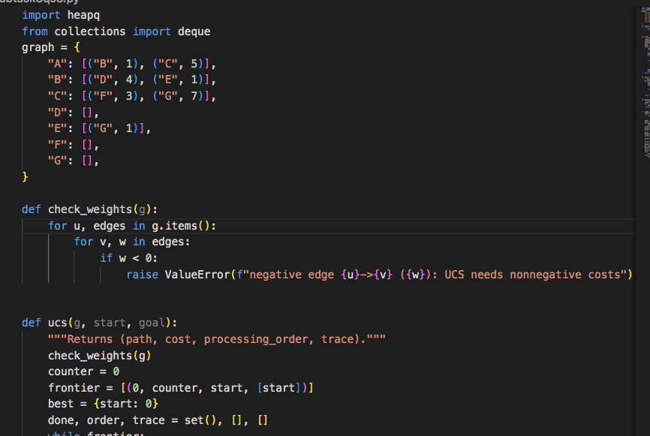

Output :


